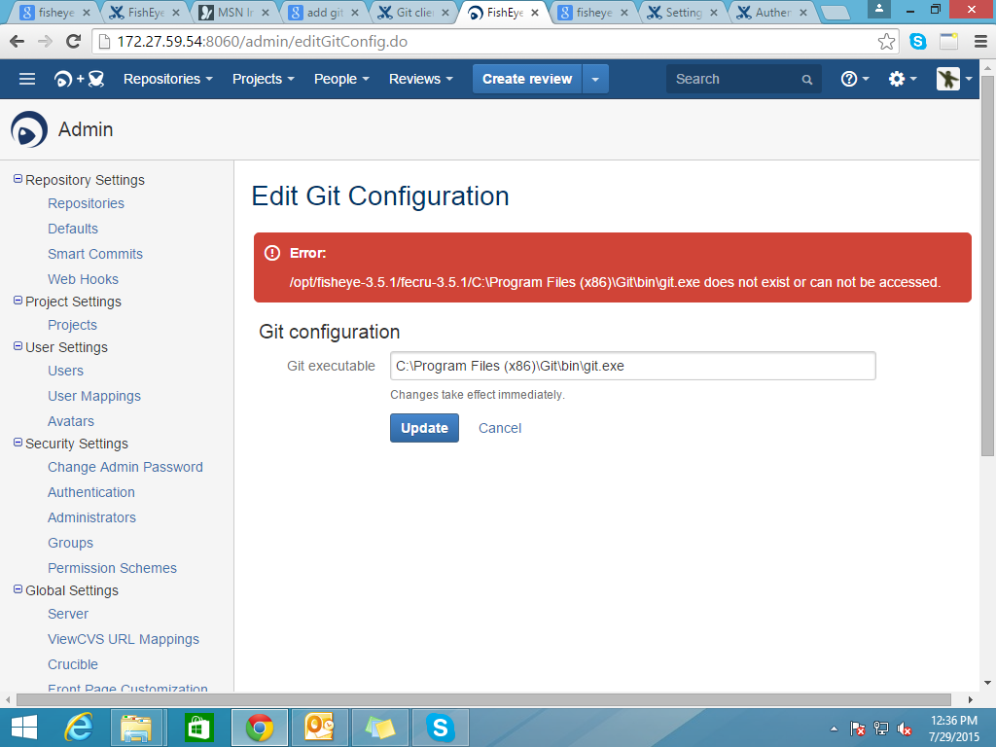

* During git configuration in fisheye this error occurred.
* Solution: set git path as Git executable :/usr/local/bin/git

# [Configuring SMTP](https://confluence.atlassian.com/display/FISHEYE/Configuring+SMTP)

https://confluence.atlassian.com/display/FISHEYE/Configuring+SMTP

To configure SMTP settings in FishEye:

1. Go to the Admin screen, click **Server** (under 'Global Settings') and look for the 'Mail Server' section.
2. Click **Edit config**.
3. You can edit the following settings:

|  |  |
| --- | --- |
| **Send emails from** | **Server address**: Fisheye and Crucible will use the **From Address** set below.  **User address**: Fisheye and Crucible will use the email address in the user's profile. |
| **From Address** | The sender address used when FishEye or Crucible sends an email, e.g. ['fisheye-noreply@example.com](https://confluence.atlassian.com/mailto:)' |
| **SMTP Host name** | The host name of the SMTP server. |
| **Enable debug** | Optional. Turn this on to enable debug logging from the mail server. Useful in tracking down mail server connectivity problems. |
| **SMTP Port** | Optional. The port to connect to on the SMTP host. FishEye needs to use port 25 or port 587, because unlike JIRA its initial connection doesn't use SSL. Port 25 will be used if no port is specified. |
| **Use SSL/TLS** | Optional, defaults to 'False'. This turns on [Secure Sockets Layer/Transport Layer Security](http://en.wikipedia.org/wiki/Transport_layer_security) security for mail servers that require it, or use it by default. |
| **Username & Password** | Optional. Username and password for authenticated SMTP access. |
| **Connection timeout** | The time in seconds to wait for a connection to the SMTP server (leave blank for infinite timeout). |
| **Timeout** | The time in seconds to wait for a response from the SMTP server (leave blank for infinite timeout). |

1. Click **Save**.

Error occurred:

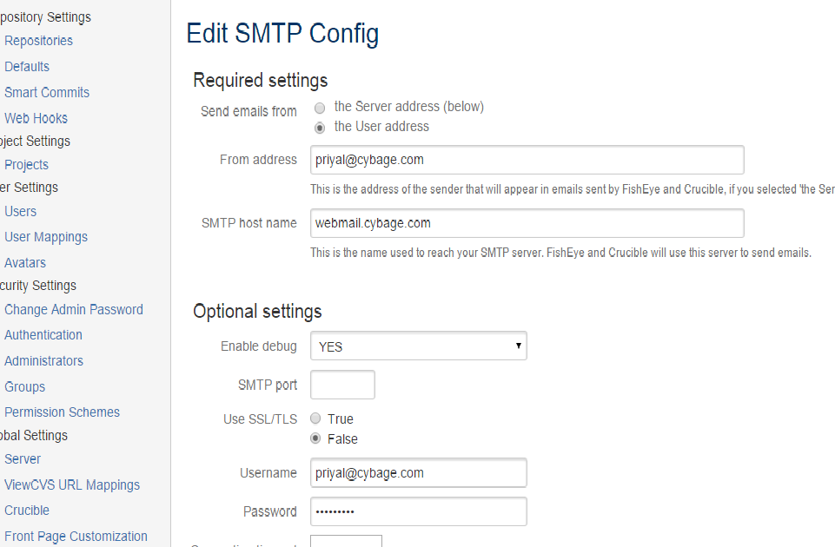

When you test mail

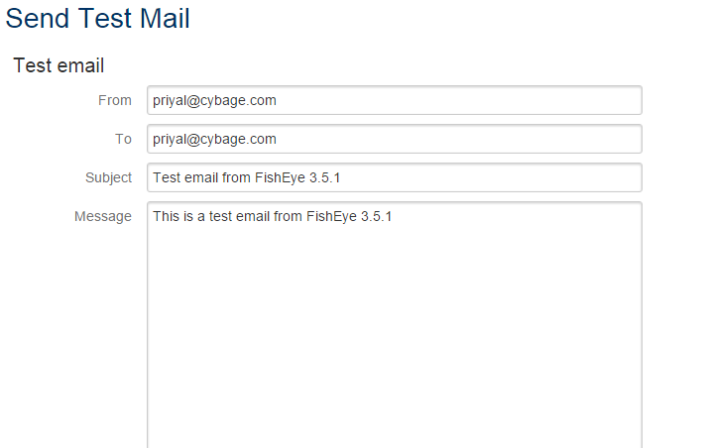

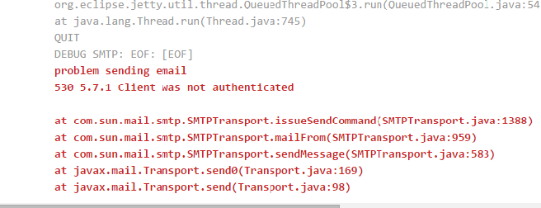

Svnrepository setup

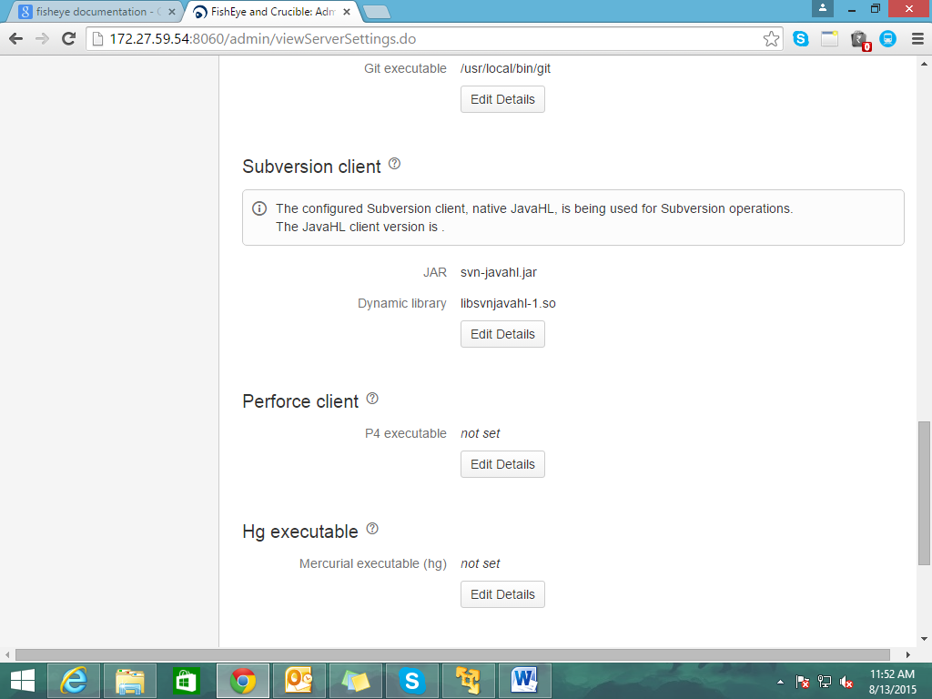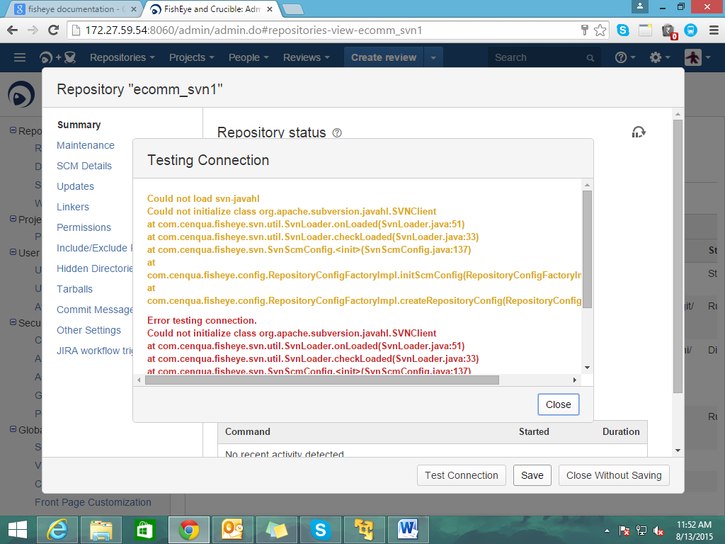

C:\Users\priyal\Desktop\ecomm2_svn>svn info svn://localhost/branches/ecomm_svn

Authentication realm: <svn://localhost:3690> 59fd3954-8410-ee4c-b395-7d11c63a8e

6

Password for 'priyal': *****

Authentication realm: <svn://localhost:3690> 59fd3954-8410-ee4c-b395-7d11c63a8e

6

Username: priya

Password for 'priya': *****

Path: ecomm_svn

URL: svn://localhost/branches/ecomm_svn

Relative URL: ^/branches/ecomm_svn

Repository Root: svn://localhost

Repository UUID: 59fd3954-8410-ee4c-b395-7d11c63a8e36

Revision: 5

Node Kind: directory

Last Changed Author: priya

Last Changed Rev: 5

Last Changed Date: 2015-08-05 18:18:13 +0530 (Wed, 05 Aug 2015)

C:\Users\priyal\Desktop\ecomm2_svn>svn info file:///C:/Users/priyal/Desktop/svn

emote

Path: svnremote

URL: file:///C:/Users/priyal/Desktop/svnremote

Relative URL: ^/

Repository Root: file:///C:/Users/priyal/Desktop/svnremote

Repository UUID: 59fd3954-8410-ee4c-b395-7d11c63a8e36

Revision: 5

Node Kind: directory

Last Changed Author: priya

Last Changed Rev: 5

Last Changed Date: 2015-08-05 18:18:13 +0530 (Wed, 05 Aug 2015)

C:\Users\priyal\Desktop\ecomm2_svn>svn info file:///C:/Users/priyal/Desktop/svn

emote/trunk/ecomm_svn

Path: ecomm_svn

URL: file:///C:/Users/priyal/Desktop/svnremote/trunk/ecomm_svn

Relative URL: ^/trunk/ecomm_svn

Repository Root: file:///C:/Users/priyal/Desktop/svnremote

Repository UUID: 59fd3954-8410-ee4c-b395-7d11c63a8e36

Revision: 5

Node Kind: directory

Last Changed Author: priyal

Last Changed Rev: 2

Last Changed Date: 2015-08-05 16:02:04 +0530 (Wed, 05 Aug 2015)